

ATILIM UNIVERSITY

COMPE-464

Image Processing

Homework-3

Name: Utku

Surname: Polat

Student ID: 160302001

***Low-pass Filter***

A low-pass filter can be applied uniquely on the Fourier transform of an image, as opposed to the original image. In the wake of applying low-pass filter on it, at that point the separated frequent image is reestablished into pixel picture, which is an obscured rendition of the original image.

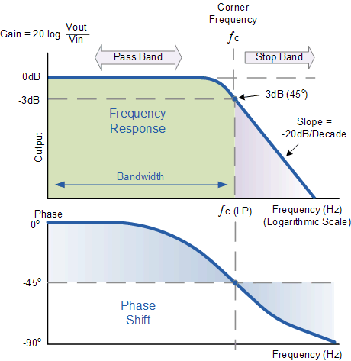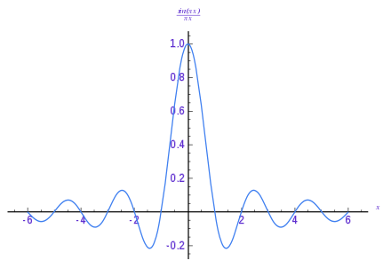

[I](https://en.wikipedia.org/wiki/Impulse_response)mpulse Response of an Ideal Low-pass Filter

Low-pass channel is only a dark scale images, whose qualities are higher close to the middle, and near zero outside.

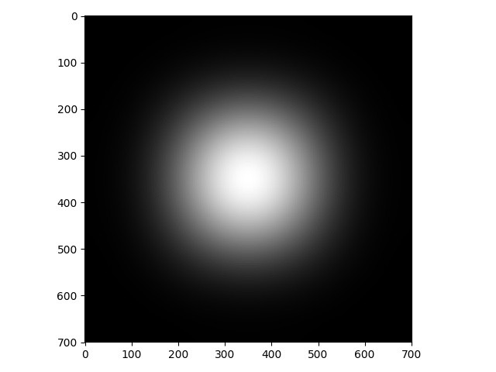

Sample Magnitude Spectrum of an Image

**Band-Reject Filter**

The BANDREJECT_FILTER work applies a low-reject, high-reject, or band-reject filter on a one-channel picture. A band reject filter is valuable when the general area of the clamor in the recurrence space is known. A band dismiss channel squares frequencies inside the picked range and lets frequencies outside of the range go through.

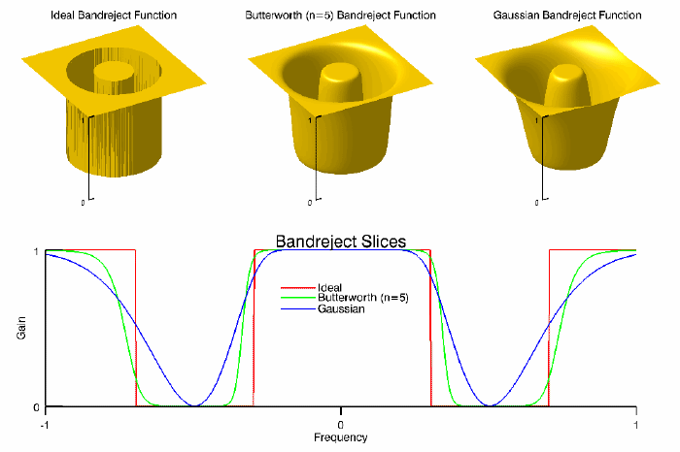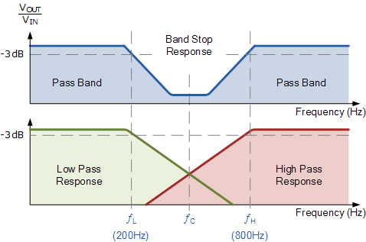

The Python Code

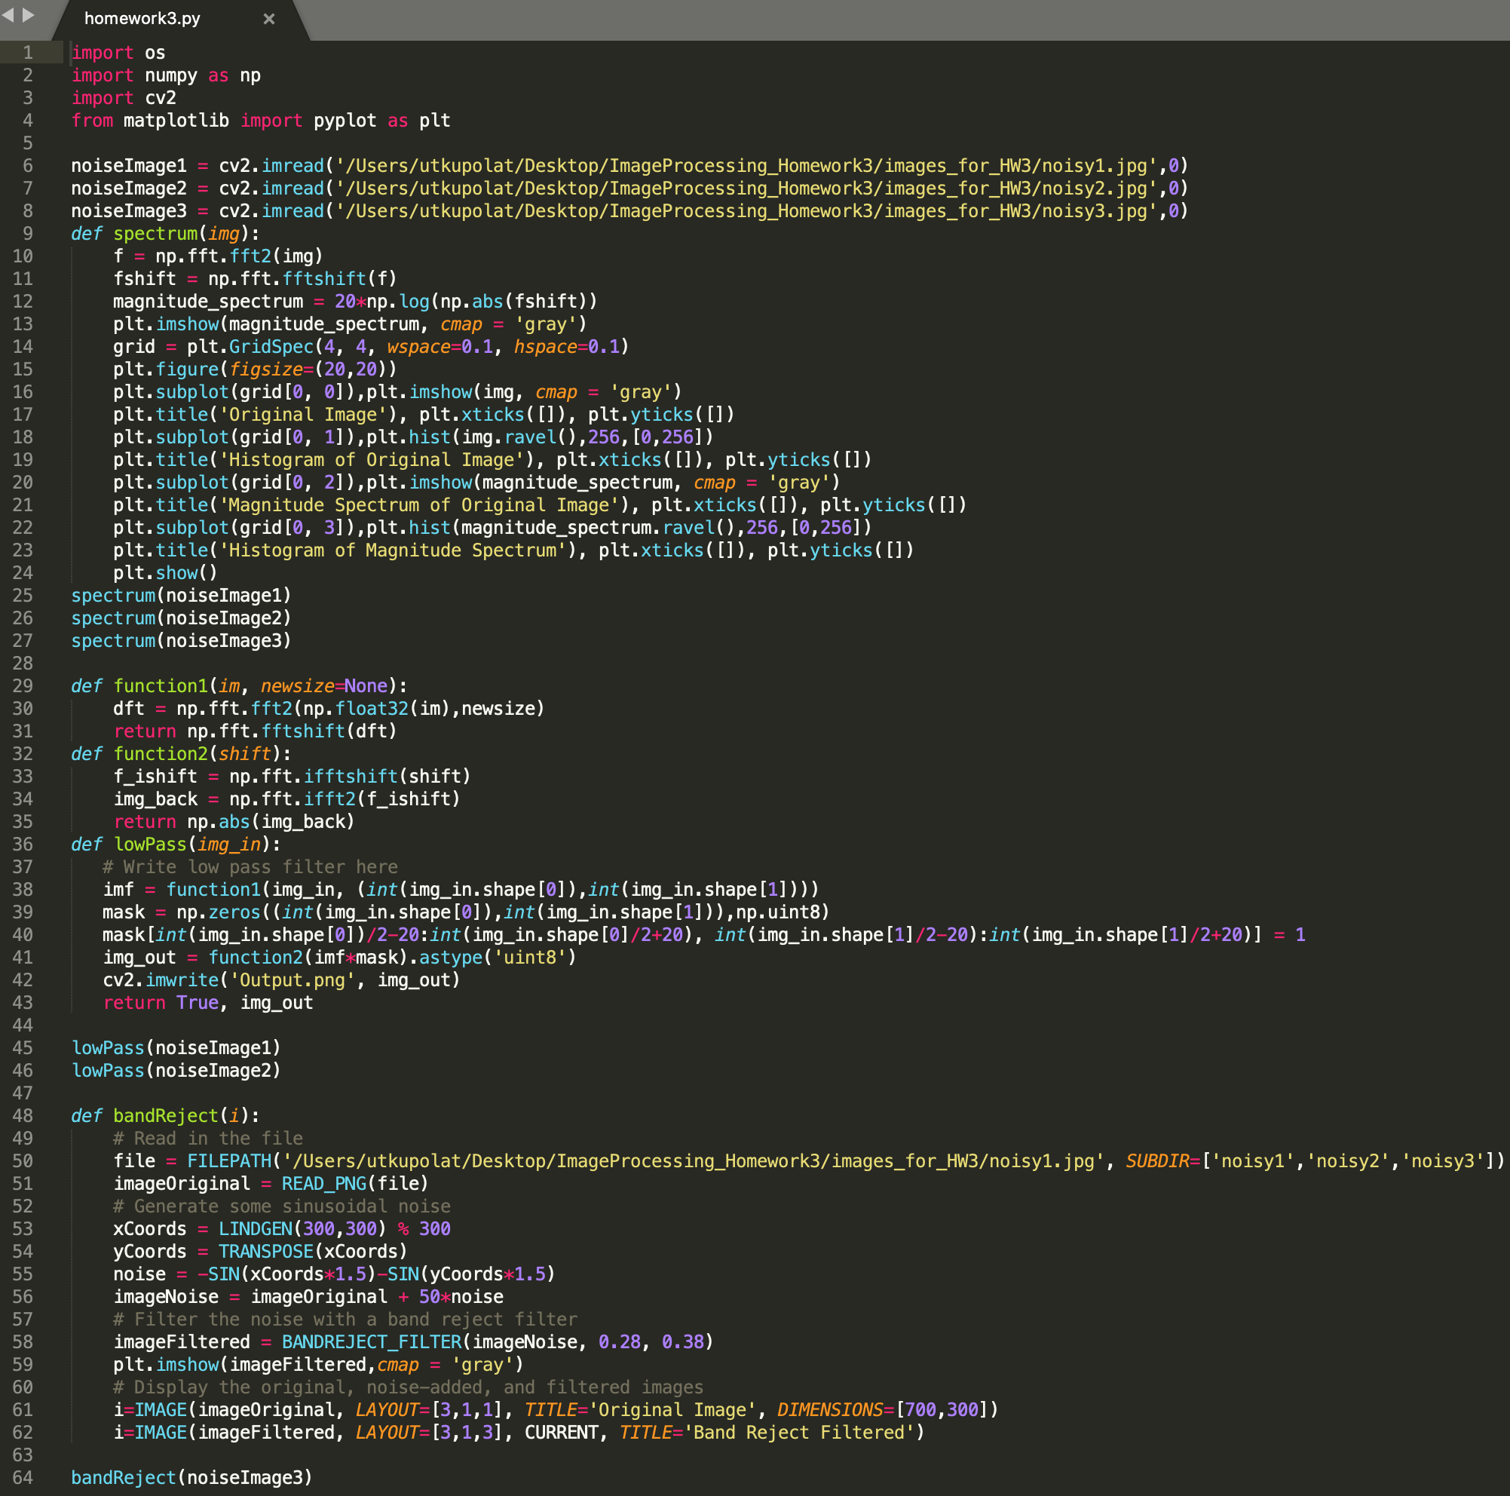

Comments

Line 1-4 => I import the necessary libraries.

Line 6-8 => Read all noisy images.

Line 9-27 => I find the histogram of original images and magnitude spectrums.

Line 29-43 => I apply the low-pass filter on the ‘noisy1’ and ‘noisy2’ images.

Line 48-64 => I apply the band-reject filter for the image ‘noisy3’.

Noisy Image 1

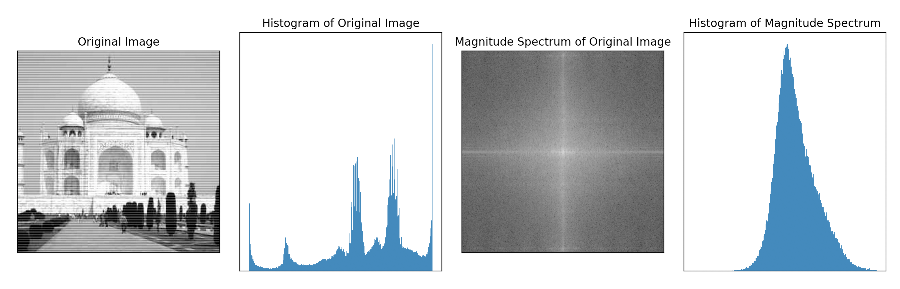Noisy Image 2

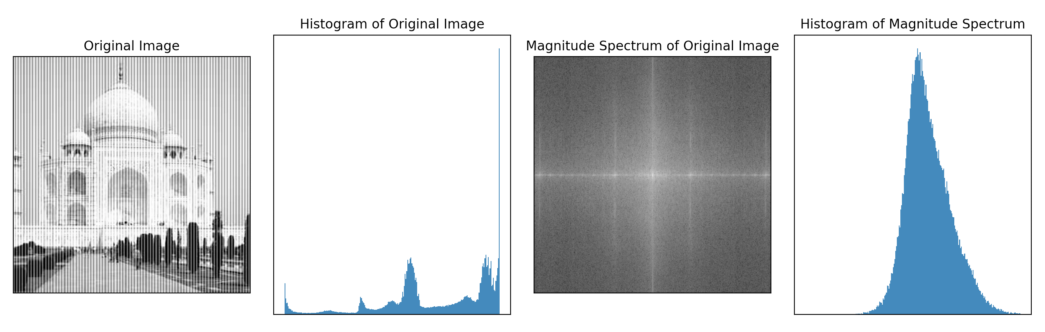Noisy Image 3

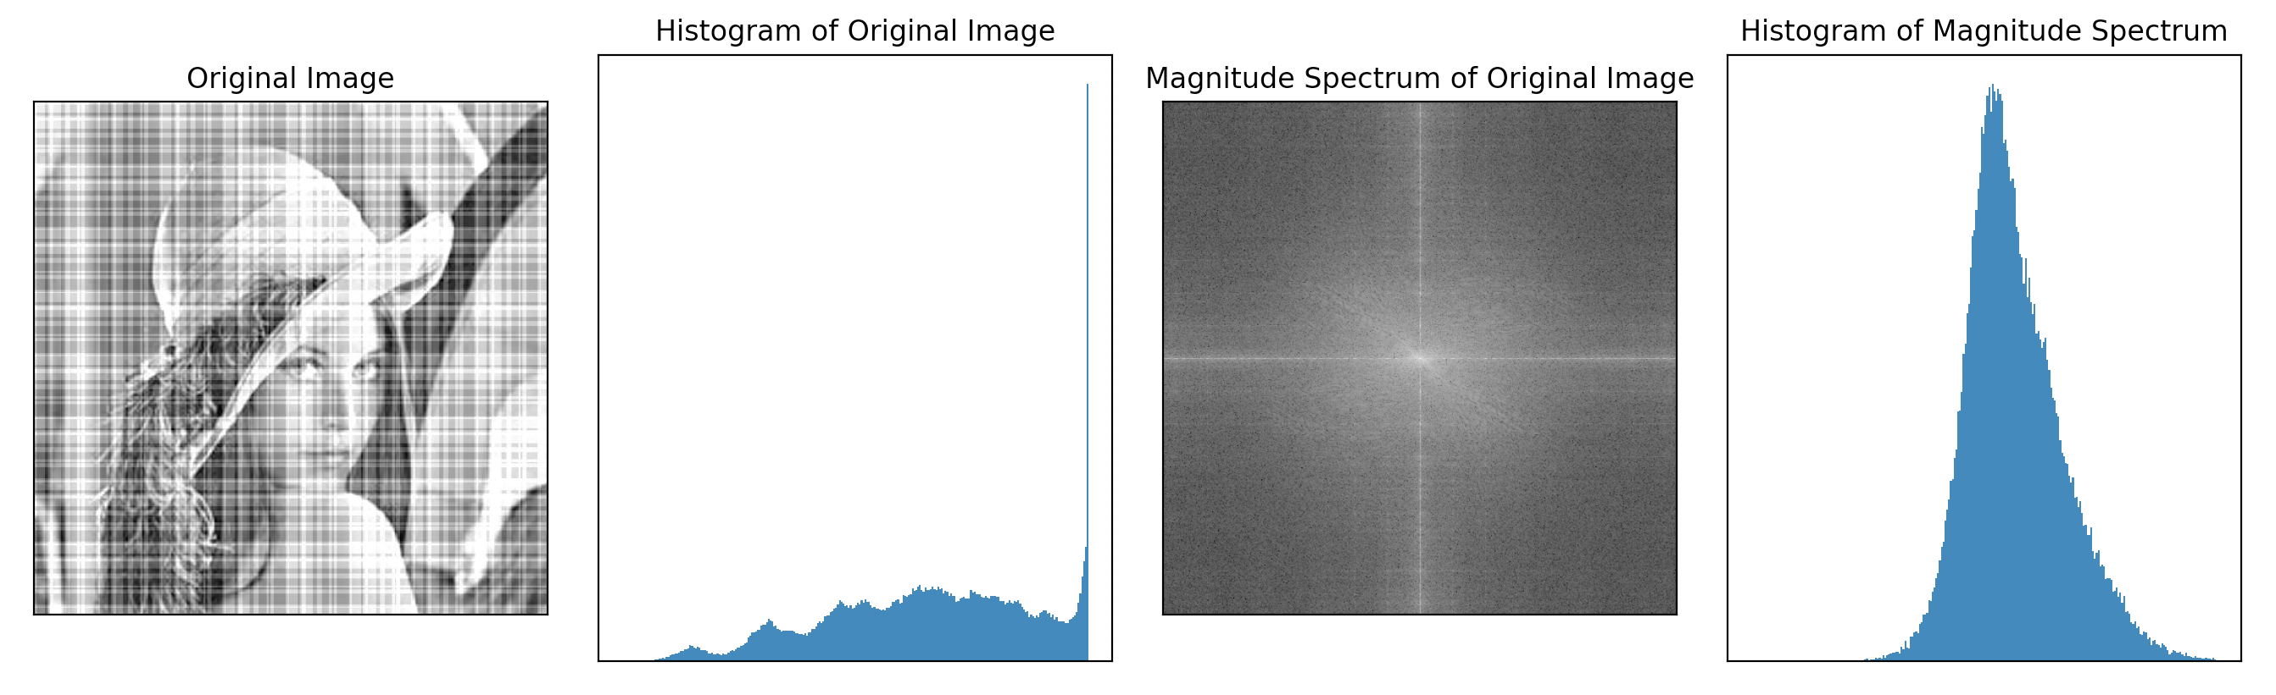

Low-Pass Filter Noisy Image 1

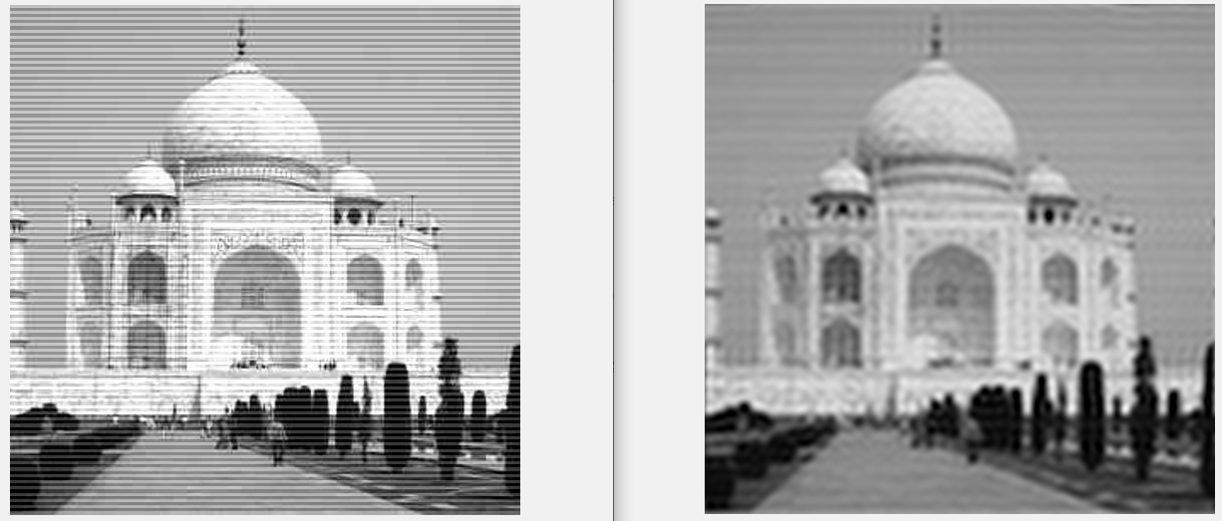Low-Pass Filter Noisy Image 2

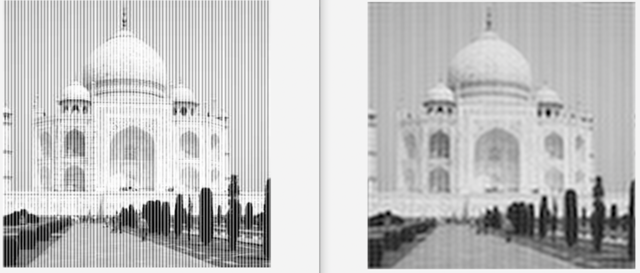Band-Reject Filter Noisy Image 3

